10 February 2025

Dear Parent/Carer

Year 11 Progress Evening Wednesday 05 March, 16:00-19:00 - Appointment Booking

I would like to invite you to meet with your child’s subject teachers on Wednesday 05 March 2025. The evening will provide an opportunity for you to discuss your child’s current progress and attitude to learning in each of their subject areas, as well as their projected achievement in their GCSE subjects.
The meetings with teachers will take place in school so that you can also purchase revision materials and speak to our Connexions Advisor.
Please visit https://monkseaton.schoolcloud.co.uk/ to book your appointments. Appointments can be made from Monday 10 February and the system will close at noon on Wednesday 05 March.

Included with this letter is a short guide on how to make bookings. You can find helpful videos to further support you by accessing the ‘Students & Parents’ section of our website: https://www.monkseaton.org.uk/progress-evening.
We believe that for your child to be successful in school and reach their full potential it is important that both home and school work together in partnership. There is no doubt that support from home is a key factor in students doing as well as possible at school and so we urge you to sign up to this event.

If you have any queries, please don’t hesitate to contact main reception on 0191 297 9700 or email at office@monkseaton.org.uk.

Yours faithfully

Roisin Wood and Laura Huskisson

Year Leaders for Year 11

Parents’ Guide for Booking Appointments
Browse to https://monkseaton.schoolcloud.co.uk/

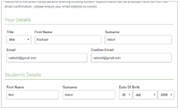 | Step 1: Login  Fill out the details on the page then click the Log In button.  A confirmation of your appointments will be sent to the email address you provide.
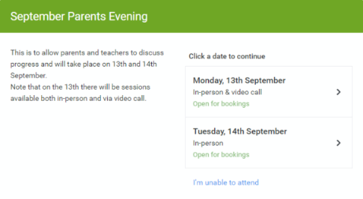 | Step 2: Select Parents' Evening  Click on the date you wish to book.  Unable to make all of the dates listed? Click I'm unable to attend.
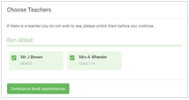 | Step 3: Choose Teachers  Select the teachers you’d like to book appointments with. A green tick indicates they’re selected. To de-select, click on their name.
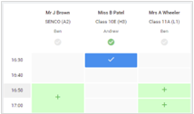 | Step 4: Book Appointments  Click any of the green cells to make an appointment. Blue cells signify where you already have an appointment. Grey cells are unavailable.  To change an appointment, delete the original by hovering over the blue box and clicking Delete. Then choose an alternate time.  You can optionally leave a message for the teacher to say what you’d like to discuss, or raise anything beforehand.  Once you’re finished booking all appointments, at the top of the page in the alert box, press click here to finish the booking process.
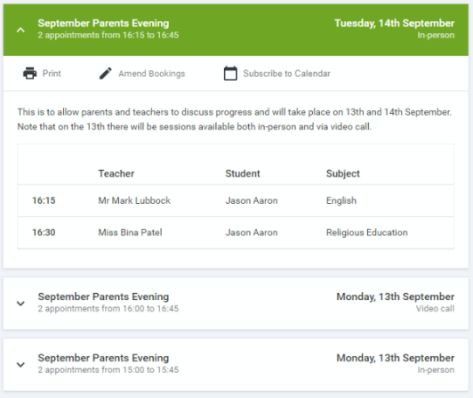 | Step 5: Finished  All your bookings now appear on the My Bookings page. An email confirmation has been sent and you can also print appointments by pressing Print. Click Subscribe to Calendar to add these and any future bookings to your calendar.  To change your appointments, click on Amend Bookings.

