10 February 2025

Dear Parent/Carer

Sixth Form Progress Evening Wednesday 19 February 2025, 16:30-18:00 - Online Appointment Booking

I would like to invite you to meet virtually with your child’s subject teachers on Wednesday 19 February 2025. The evening will provide an opportunity for you to discuss your child’s current progress and attitude to learning in each of their subject areas, as well as their projected achievement in their Key Stage 5 subjects.
The meetings with teachers will take place using School Cloud, an online software for virtual progress evenings, that can be accessed from a smart phone, laptop or PC. School Cloud has a highly intuitive, user-friendly online appointment booking system which will allow you to choose your own appointment times with teachers and you will receive an email confirming your appointments.
Please visit https://monkseaton.schoolcloud.co.uk/ to book your appointments. The system allows you to book and then attend the appointment by video. Appointments can be made from noon on Monday 10 February and will close at noon on Wednesday 19 February.

Please note, each meeting is 5 minutes in length. This is timed by the system and you will be able to see it counting down. When it reaches zero seconds, the video will cut off automatically. The teacher will then join their next meeting.
Included with this letter is a short guide on how to make bookings, and information on how to log on to the system for the appointment. You can find helpful videos to further support you by accessing the ‘Students & Parents’ section of our website: https://www.monkseaton.org.uk/progress-evening.
We believe that for your child to be successful in school and reach their full potential it is important that both home and school work together in partnership. There is no doubt that support from home is a key factor in students doing as well as possible at school and so I urge you to sign up to this event. If you have any queries please don’t hesitate to contact main reception on 0191 297 9700 or email at office@monkseaton.org.uk.

Yours faithfully

Rachel Orr

Year Leader for Sixth Form
Parents’ Guide for Booking Appointments
Browse to https://monkseaton.schoolcloud.co.uk/

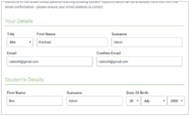 | Step 1: Login  Fill out the details on the page then click the Log In button.  A confirmation of your appointments will be sent to the email address you provide.
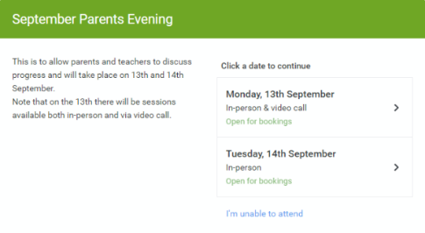 | Step 2: Select Parents' Evening  Click on the date you wish to book.  Unable to make all of the dates listed? Click I'm unable to attend.
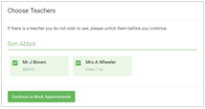 | Step 3: Choose Teachers  Select the teachers you’d like to book appointments with. A green tick indicates they’re selected. To de-select, click on their name.
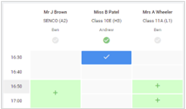 | Step 4: Book Appointments  Click any of the green cells to make an appointment. Blue cells signify where you already have an appointment. Grey cells are unavailable.  To change an appointment, delete the original by hovering over the blue box and clicking Delete. Then choose an alternate time.  You can optionally leave a message for the teacher to say what you’d like to discuss, or raise anything beforehand.  Once you’re finished booking all appointments, at the top of the page in the alert box, press click here to finish the booking process.
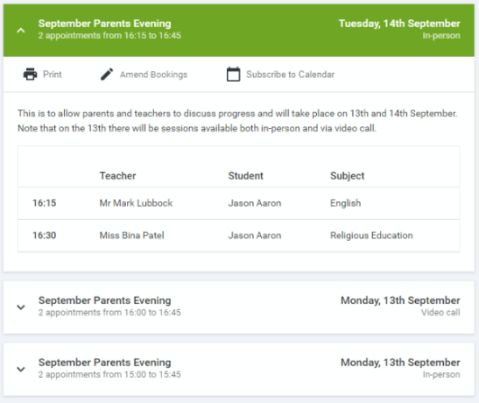 | Step 5: Finished  All your bookings now appear on the My Bookings page. An email confirmation has been sent and you can also print appointments by pressing Print. Click Subscribe to Calendar to add these and any future bookings to your calendar.  To change your appointments, click on Amend Bookings.

