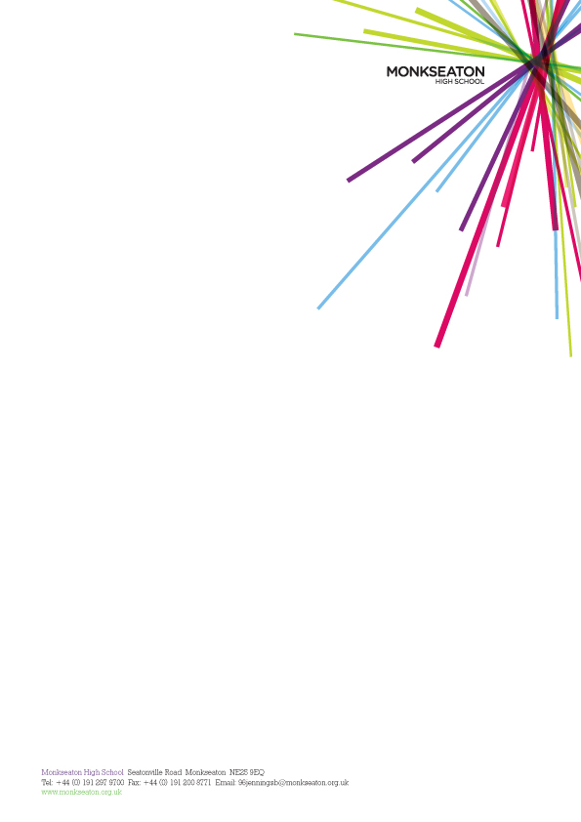**MONKSEATON HIGH SCHOOL**

**LEARNING SUPPORT ASSISTANTS**

* APT&C Grade 5 (£20,804 – 21,895 FTE)  * pay award pending
* Full time / Part Time
* Term Time Only + 5 days
* Start date – September 2024

**Closing Date: 10:00 Thursday 12th September**

We are seeking to appoint enthusiastic, self-motivated and flexible individuals, to join our team of Learning Support Assistants. This is an exciting opportunity to join our team of staff in a school that prides itself on its ethos of inclusion, equality, opportunity and achievement.

The successful candidates will need outstanding interpersonal skills and will work closely with students. The main aspect of the role is to be a part of a team to support young people with individual needs within lessons. The successful applicants will also be involved in the implementation and monitoring of support programmes for individual students. You will need to be good humoured, resilient and enjoy working with young people aged 13 – 18.

Monkseaton High School is committed to safeguarding and promoting the welfare of children and young people and we expect all staff and volunteers to share this commitment. As such an enhanced Disclosure and Barring Service (DBS) disclosure will be sought along with other relevant employment checks deemed appropriate.

All staff who join the school benefit from a carefully structured programme of training and support.

All applicants are welcome to contact the school before applying.

Application forms and further details are available on our website [www.monkseaton.org.uk](http://www.monkseaton.org.uk)

Please ensure you provide a covering letter, or your application may not be considered.

**Applications should be returned to the school by 10:00 Thursday 12th September**

Your application may be submitted either electronically to:[**recruitment@monkseaton.org.uk**](mailto:recruitment@monkseaton.org.uk) or in paper form marked for the attention of Mrs MA Dowson. Paper copies to be sent to Monkseaton High School, Seatonville Road, Whitley Bay, Tyne and Wear, NE25 9EQ.

*Please note Monkseaton High School is committed the Safer Recruitment and Safeguarding Children and Young People. Any submissions received with an incomplete application form* ***will not be considered****. A Curriculum Vitae will not be accepted alone.*